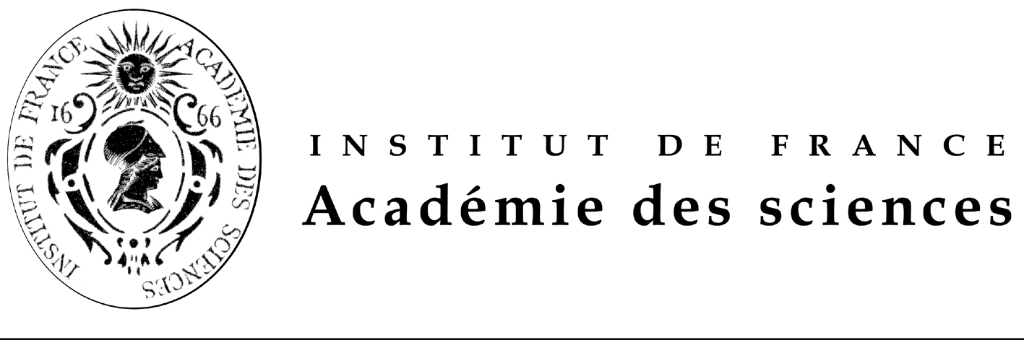

FONDATION FRANCO-CHINOISE POUR LA SCIENCE ET SES APPLICATIONS (FFCSA)
POST-DOCTORAL FELLOWSHIPS OFFERED

PROMOTION 2010
(18 months, exceptionally 24 months)

Call for candidates: September 29th, 2009

FFCSA’s Fellowships are awarded for 18 months, exceptionally 24 months.
They are exclusively aimed at candidates living in mainland China who wish to come to France. Chinese scholarship holders currently in France who are seeking to extend their stay are not eligible to apply.

Fellowships offered are aimed exclusively at post-doctoral scholars, who have obtained their Ph.D. before the end of December 2009 and within the last 6 years and are under 35 years of age. A fluent knowledge of English is a pre-requisite for admission

Selection of candidates is a three-stage process:

- call of offers, and short-listing of candidates in China, under the guidance of China Scholarship Council (CSC) and the Chinese Academy of Sciences (CAS) which select three times as many candidates as there are fellowships on offer;

- interviews in China, in Beijing and Shanghai, by an FFCSA expert panel from France (candidates’ travel costs to the interview locations are at the candidates’ expense);

- Final decision in France by the FFCSA’s Scientific Council on the candidates selected and on their host laboratories in France, with the confirmation of CSC and the CAS,.

The timetable for the fellowships promotion 2010 award is as follows:

  - September 29 th, 2009: Call of proposal publication in French, English and Chinese of the Fellowships offered for promotion 2010 (18 months) and exceptionally 2008-2010 (24 months)

  - December 28th, 2009: deadline for applications in China and in France;

  - From January 11th 2010 to January 15th 2010: interviews of short-listed candidates in Beijing or Shanghai by representatives of the FFCSA’s Scientific Council; ranking of candidates for each fellowship offered;

  - From February 20th 2010 to February 27th, 2010: final decision on candidates selected by the FFCSA’s Scientific Council, with the confirmation of CSC and the CAS; candidates selected will be immediately informed and will be required to start learning French intensively before leaving China (French training lessons in charge of the CSC).

  - March-July 2010: French training lessons in China

  - September- October 2010: arrival in France of candidates selected.

The international plane fare from China to France and return is taken in charge by the CSC. The travel cost to provincial France when necessary will be covered by the FFCSA. The amount of the fellowship is € 2 300 net per month. The cost of health insurance is covered by the FFCSA.

Whichever the date corresponding at research work during the fellowship, publications should mention imperatively the help of the FFCSA and CSC.

During his/her stay in France, each scholar will be counselled by the FFCSA whose task is to ensure the harmonious integration of the scholar and the smooth development of his/her research programme. The scholar’s return to China is mandatory. FFCSA had created an Alumni Club in January 2005.

For the class 2010, 18 months exceptionally 24 months, beginning September-October 2010, the number of fellowships offered is 28 in the following subjects:

- A new generation of nanoscale optical biosensor
- Charge density studies on vanadium compounds
- Virtual testing dedicated to unidirectional and/or fabric composite materials
- Study of Multi-Input Multi-Output Wireless Optical Communication Systems, Application to a Sensor Network
- Sex-specific epigenetic marks as targets for nutritional prevention of type 2 diabetes
- Cellular mechanisms of neuromuscular diseases (cell biology of membrane and organelles trafficking, physiopathology of mice models)
- Medicinal Chemistry
- Aerospace Mechanical Engineering Dynamic damage in structure
-. Role of TASK potassium channels in the development of primary aldosteronism.
- Synthesis of aromatic and heterocyclic ion conducting polymers for the elaboration of membranes for fuel cell applications
- Plastid glycolipid assembly in the plant Arabidopsis thaliana, a model to characterize promising therapeutical targets to fight against major human pathogens including the malaria parasite Plasmodium falciparum
- Deciphering flower development in Rosa sp.
- Pathogenesis studies for cysteine mutation of the Notch3 receptor in the CADASIL vascular dementia
- ZnO: growth of transition metals and interfacial reactivity
- Oxide nanoparticles for energy storage with high power density
- Homogeneous catalysis for the Total synthesis of Biomolecules
- Research on future 3GPP Wireless networks to offer very high throughput while covering a full city
- Improvement and design of new Biologic waste water treatment units
- Sustainable development indicators set up for processes and products
- Physics and Physical chemistry of soil attributes
- Process development in an Innovation project
- Diabetes, Metagenomics and Traditional medicine
- Clay-based Nanocomposites (including modified clay and polylmer composites, clay and metal oxide composites. etc.)
- Development of a novel generation of photovoltaic cells based on semiconductor nanoparticles
- Development of one ”Evolution machine”
- Geochemistry
- Materials / Mechanicals structures in nuclear equipments
- Scanning probe microscopy in phase separated manganites

IMPORTANT
If the applicant chooses 2 thematics, he /she has to give his/her preference whether A or B
Candidates application’s package should include (see the application form)
-a detailed CV,
-a motivation letter pointing out either the suitability of your CV,
-the scientific publications,
-the research grants,
-and two letters one from the head of the laboratory and one from the President of their University or from a Science Academician if he or she is not working in a University.

Candidates should send their application package by e-mail at all the following addresses ffcsa@academie-sciences.fr and zlzhu@csc.edu.cn and xflu@cashq.ac.cn

The deadline is December 28 th, 2009. Applications should be send in parallel by mail to Mr ZHU Zhilong, e mail : zlzhu@csc.edu.cn Project Officer, Division of Cooperation and Consultancy, China Scholarship Council,9-A3 Chegongzhuang street Beijing 100044, P.R.China.

The China Scholarship Council will inform the FFCSA and the Chinese Academy of Sciences of the progress timely.

Chinese version and forms are available at URL: http://www.casbic.ac.cn , the post-doctoral fellowships offered is also available at URL http://www.csc.edu.cn and French and English versions are available at URL
http://www.academie-sciences.fr/international/fondation_chine_fr.htm or
http://www.academie-sciences.fr/international/fondation_chine_gb.htm

